NFL Teams Split Record $7.8 Billion in 2016, Up 10%
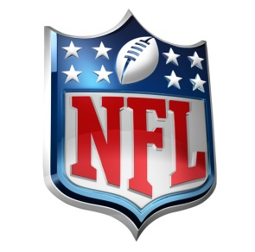
Each NFL team receives an equal share of the league's "national revenue" -- primarily money from television deals, but also league-wide sponsorships, licensing and merchandise sales. The Packers, the only publicly owned franchise in major U.S. sports, reported Wednesday that they got $244 million, up from $222.6 million last year.
Advertising Age 7.12.17
http://adage.com/article/media/nfl-teams-split-record-7-8-billion-2016-10-percent/309737/?utm_source=daily_email&utm_medium=newsletter&utm_campaign=adage&ttl=1500548613&utm_visit=113450

