Nielsen Boosts Cross-Media Measurement With Wearables
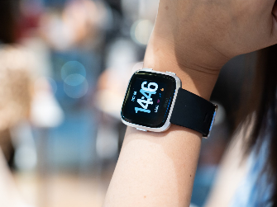
Some 3,000 Nielsen Portable People Meter panelists will be equipped with Bluetooth-enabled wearable measuring devices in September as the ratings giant works to improve participation and compliance outside the home. The devices will capture radio and television consumption in different rooms of houses, in panelists' vehicles and in public venues, increasing cross-media measurements for the Nielsen ONE platform.
Inside Radio (free content) 8/5/21
http://www.insideradio.com/free/wearable-ppms-are-radio-s-on-ramp-to-nielsen-one/article_c5850968-f5ba-11eb-a917-833ccdd6a3ef.html
Image credit:
https://detektor.fm/digital/fortschritt-wearables-im-trend

