Nielsen Faces Competition, Criticism in the Digital Age
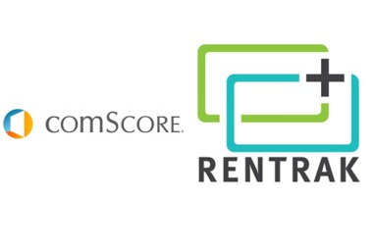
Nielsen has competition on the horizon in the form of the newly merged comScore and Rentrak, and critics say the outdated ratings system needs to advance to keep up with changes in technology in the digital age. Nielsen has released 69 products and technological innovations, and it plans to replace its paper diaries with electronic devices.
The New York Times 2/2/16
http://www.nytimes.com/2016/02/03/business/media/nielsen-playing-catch-up-as-tv-viewing-habits-change-and-digital-rivals-spring-up.html?WT.mc_id=SmartBriefs-Newsletter&WT.mc_ev=click&ad-keywords=smartbriefsnl&_r=0

