Nielsen Launches Test System With Studio, Agency Backing
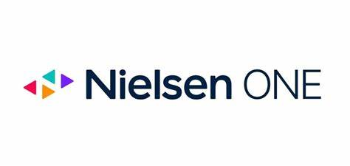
The alpha version of the Nielsen One cross-platform measurement tool, which debuted this week, has signed on initial clients, including Disney, Sony Pictures Television, TelevisaUnivision, Horizon Media, AMC Networks and Mediahub. The platform, which Nielsen hopes to bring to the wider market later next year, will likely evolve before its official launch, Nielsen says.
MediaPost Communications (free registration) 5.3.23
https://www.mediapost.com/publications/article/384975/nielsen-deploys-nielsen-one-content-alpha.html

