Nielsen's Rollout of Portable People Meters Moved to January
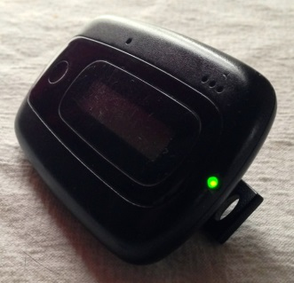
All but one of the markets that use Nielsen's Local People Meters will have to wait until January for the portable versions. The new metric rollout was expected in the fall but was delayed to give Nielsen more time to work out some complications, such as moving from transaction-based to impression-based ratings.
TVNewsCheck (free registration) 11/28/18
https://tvnewscheck.com/article/226021/waiting-game-better-ratings-continues/
Image credit:
https://upload.wikimedia.org/wikipedia/commons/f/f8/Arbitron_Portable_People_Meter.jpg

