Nielsen Says Radio Streaming Numbers Have Doubled
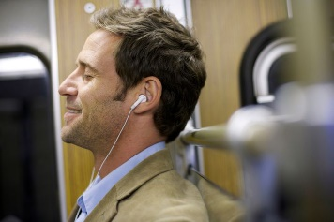
Nielsen reports that 10% of radio audiences use digital streaming to listen, double the rate that did so a year ago. "Share of Ear" data indicates that streaming audiences account for 13% of radio listeners between 18 and 34 and 11% of those between 35 and 64.
Inside Radio (free content) 5/18/21
http://www.insideradio.com/free/nielsen-10-of-all-radio-listening-now-takes-place-online/article_713850b8-b7a3-11eb-bcd0-770fefd0d560.html
Image credit:
https://pyxis.nymag.com/v1/imgs/79a/25e/37da390295be54cbc1cfa6143a45454127-13-childrens-audiobooks.h473.w710.jpg

