Nielsen to Measure Podcasts In 2017
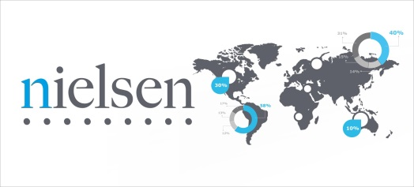
Our intent all along has been to measure all types of digital audio content. AM and FM, which is what we’ve been focused on, those digital streams, music streaming services, we want to be able to measure that, and on-demand podcasting. We’ve been kind of testing things out with ESPN. (Rob Kass, Nielsen’s Vice President of Digital Audio.)
RadioInk 9.21.16
http://radioink.com/2016/09/21/nielsen-measure-podcasts-2017/?utm_source=ActiveCampaign&utm_medium=email&utm_content=Smulyan%3A+We+Will+Get+NextRadio+On+The+iPhone&utm_campaign=THURSDAY+9+22+Berner+Culture

