Nielsen to Retire Paper Diaries in 2018
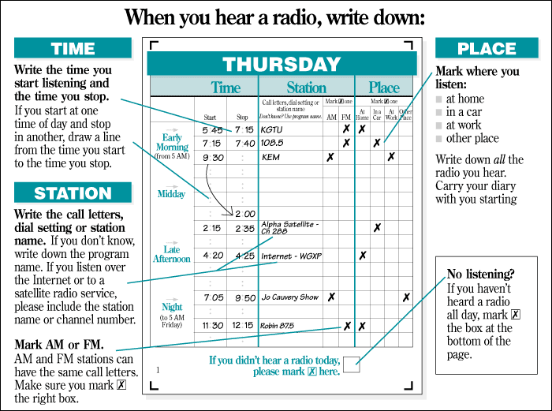
Nielsen on Wednesday announced that it will incorporate Return Path Data and other electronic measurements in 140 local TV markets by July 2017. This new system will be used to retire paper diaries by early 2018 and will provide "consistent measurement, true-person exposure data and complete local market coverage ... 365 days a year," the company said.
Radio Business Report 9/14/16
http://rbr.com/nielsen-tv-diaries-091516/

