Nielsen Unit Will Distribute Live Sports Data to TVs, Cars
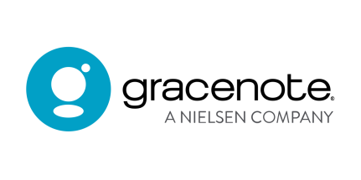
Nielsen's Gracenote division will provide smart televisions and connected car systems with live sports scores, statistics and news. Gracenote Sports Data's technology will also let smart TV companies offer game previews, including data about live broadcast and streaming outlets.
MediaPost Communications (free registration) 1/6/21
https://www.mediapost.com/publications/article/359273/nielsens-gracenote-to-provide-real-time-sports-da.html

