How Nike, Others Exemplify Values Through Marketing
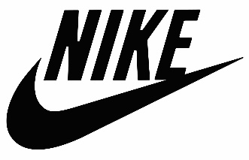
Brands are catching on to consumers' increased desire for brand values and transparency with campaigns that amplify these traits. Effective campaigns from leading brands taking a stand include Nike's "For Once, Just Don't Do It" social effort supporting the Black Lives Matter movement and Pernod Ricard's #EngageResponsibly promotion to thwart hate speech, which includes the support of the Association of National Advertisers.
Econsultancy 2/18/21
https://econsultancy.com/brand-campaigns-that-took-a-stand-on-social-issues/

