Nissan Takes Whole-Organization Approach to Social Listening
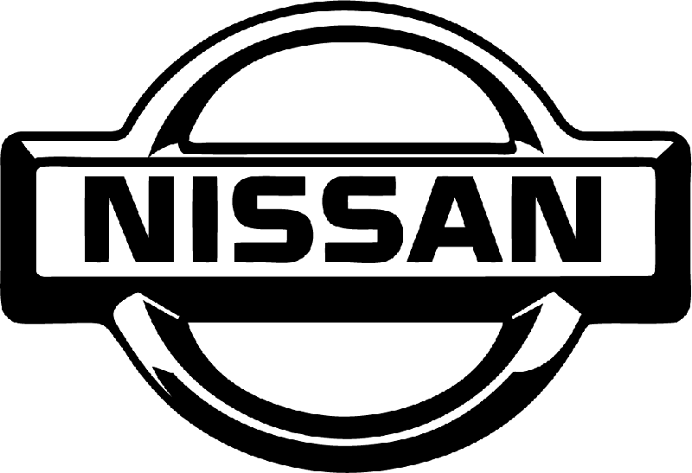
Nissan Motor is using a hybrid model of social customer service, with its online team not fitting easily into any vertical, social media chief Bryan Long says. The team has an open command center that holds presentations to spread the word internally about its work.
SocialMedia.org's Blog 7/12/16
http://socialmedia.org/blog/bryan-long-on-the-state-of-social-media-at-nissan/

