Noticias Telemundo Reporter Abducted in Venezuela, Network Says
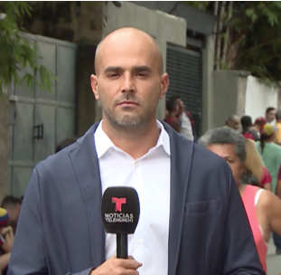
According to Noticias Telemundo, when Garrido was kidnapped he was reporting on a Univision news crew that the day before was detained and then deported by Venezuelan authorities. The network says “a group of unidentified armed men” put a hood over Garrido’s head and forced him into a vehicle, took him to a separate location and questioned him for approximately six hours.
The Wrap 2.26.19
https://www.thewrap.com/noticias-telemundo-reporter-abducted-in-venezuela-network-says/
Image credit:
https://s3.amazonaws.com/abn-prod/wp-content/uploads/sites/3/2019/02/Daniel_Garrido_.png

