Ogilvy, Dove Spotlight "Toxic Influence"
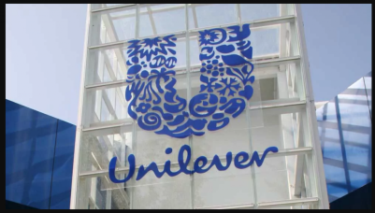
Ogilvy created a short "Toxic Influence" film for Dove that features real women and their daughters sitting down to talk about social media before being shown videos that use deepfake technology to turn the moms into the influencers, dispensing toxic advice such as using a nail file to fix uneven teeth. The film shows the shocked moms realizing what their daughters see online all the time and forms part of the brand's"#DetoxYourFeed" campaign.
The Drum (free registration) 4/27/22
https://www.thedrum.com/news/2022/04/27/ad-the-day-dove-deepfakes-highlight-toxic-beauty-advice-social-media

