Orlando Radio Stations Provide Support Following Nightclub Shootings
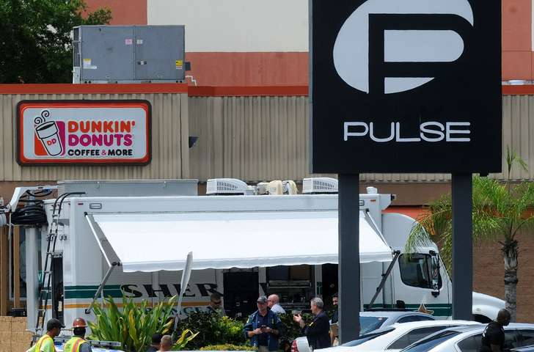
Orlando radio stations on Sunday suspended their traditional broadcasts and brought local listeners news and updates on the Pulse nightclub massacre. Stations such as News 96.5 WDBO, Star 94.5 WCFB and WMMO provided continuous coverage and community support through a simulcast aired from a News 96.5 studio.
Inside Radio 6/13/16
http://www.insideradio.com/free/orlando-radio-mobilizes-in-response-to-mass-shooting/article_041dab2c-3139-11e6-9803-075e0a9864de.html

