Oscars Slap Response And Communications Lessons Learned
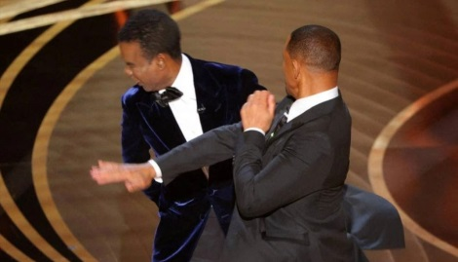
Reputation Partners' Brendan Griffith examines how the Academy of Motion Pictures Arts and Sciences and Will Smith handled massaging after the actor slapped comedian Chris Rock during the Oscars telecast. Griffith highlights three lessons public relations professionals can learn from the ensuing communications.
PR Daily 4/12/22
https://www.prdaily.com/3-crisis-communications-lessons-from-the-academys-oscars-slap-response/
Image credit:
https://otakukart.com/wp-content/uploads/2022/03/Will-smith-chris-rock-oscars-2022-1068x612.jpg

