Out-Of-Home Ads Experimenting with Consumer Interaction
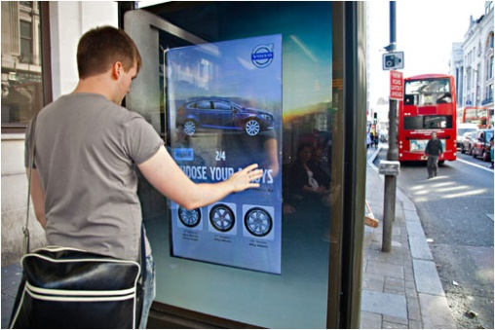
Brands are embracing increasingly sophisticated outdoor advertising to engage with consumers, such as an interactive campaign from National Geographic and the Outdoor Advertising Association of America that employed digital billboards and selfies to spotlight the plight of endangered species. A push for Amazon Prime's original show "Catastrophe" enabled people in New York City to tweet their suggestions for future shows on digital billboards.
MarTech Advisor 6/2/17
https://martechtoday.com/interactive-ooh-coming-of-age-199079
image credit:
http://screenmediadaily.com/wp-content/uploads/2013/05/Volvo_test_drive.jpg

