Over $3B Spent On Midterm Local TV Ads
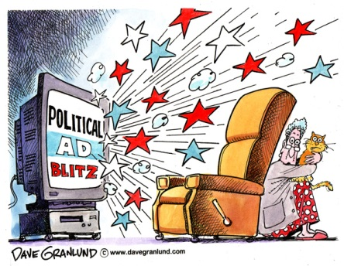
“Campaigns, PACs and other entities spent over $3 billion dollars on local broadcast television advertising in the 2018 midterm cycle,” said TVB President-CEO Steve Lanzano. “There is no doubt that local broadcast TV delivers for political campaigns. Candidates continue to derive tangible, winning results from local broadcast television. Tuesday’s dominant reliance on TV, over all other media platforms, demonstrates that voters rely on local broadcast TV to inform their voting decisions.”
TVNewsCheck 11.7.18
https://tvnewscheck.com/article/top-news/225083/3b-spent-midterm-local-tv-ads/?utm_source=Listrak&utm_medium=Email&utm_term=Over+%243B+Spent+On+Midterm+Local+TV+Ads&utm_campaign=Over+%243B+Spent+On+Midterm+Local+TV+Ads
Image credit:
https://cc.media/wp-content/uploads/2016/03/political-ad.jpg

