P&G Seeking to Trademark Social Acronyms Like LOL
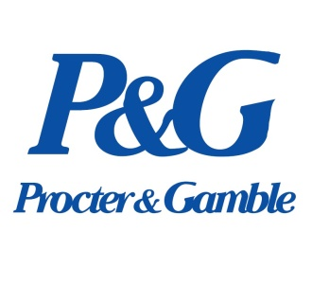
Procter & Gamble is trying to trademark acronyms such as LOL and NBD so that it can place the social media lingo on its products to connect with millennial buyers. The company is facing increasing competition from startup brands, some of which it has acquired, such as Native deodorant.
The Drum (Scotland) 8/24/18
https://www.thedrum.com/news/2018/08/24/pg-not-the-first-brand-attempt-wtf-trademarking

