FCC’s Cross-Ownership Rule Is All About Politics
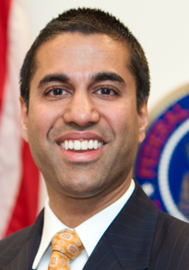
Speaking before the Kansas Association of Broadcasters this week, FCC Commissioner Ajit Pai said the Commission’s decision to retain the newspaper-broadcast cross-ownership rule was a “profound mistake.” Pai believes investments in newsgathering are more likely to be profitable when a company can distribute information over multiple platforms.
RadioInk 10.11.16
http://radioink.com/2016/10/11/fccs-cross-ownership-rule-politics/?utm_source=ActiveCampaign&utm_medium=email&utm_content=If+Trump+Loses+Big%2C+Can+Talk+Radio+Survive%3F&utm_campaign=10+12+wEDNESDAY+SYKES

