Pai Proposes Changes to Lifeline Subsidy Program
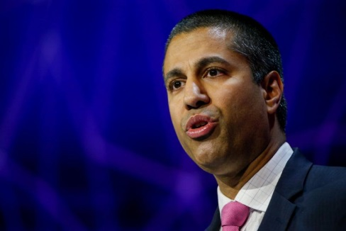
Federal Communications Commission Chairman Ajit Pai is proposing changes to the Lifeline subsidy program. Proposed changes include increasing portability, providing targeted support for residents of tribal lands and implementing a self-enforcing cap.
Broadcasting & Cable 10/27/17
http://www.broadcastingcable.com/news/washington/pai-proposes-own-lifeline-revamp/169688
Image credit:
https://www.uschamber.com/sites/default/files/styles/article_gallery/public/articles/images/bloomberg_ajit_pai_mobile_world_spain_1600px.jpg?itok=42hMla8J

