Palm Springs Post: From Daily Newsletter To Thriving News Outlet
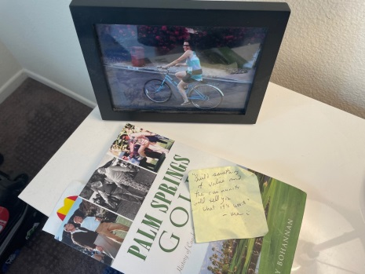
In the last two years, the Palm Springs Post has grown from a newsletter with 1,500 subscribers to one with 13,000. Editor-in- chief Mark Talkington says the outlet has been successful because it fills a gap of “basic community news coverage centered around city hall.”
Indiegraf 2.21.23
https://indiegraf.com/palm-springs-post-1500-newsletter-subscribers-into-a-thriving-news-outlet/
Image credit:
https://thepalmspringspost.com/wp-content/uploads/2021/09/StickyNoteMarkTalkington-1536x1152.jpg

