Pandemic Lockdowns Fuel Social Media Usage
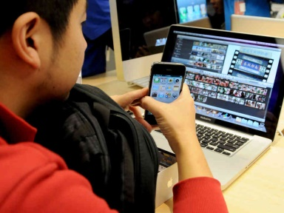
A GlobalWebIndex report says that internet users around the world have increased their average number of social media accounts to 8.1, up from 7.6 in 2017. Nearly half of those surveyed turn to social media for news, though just 14% see social media as the "most trustworthy source," writes Tyrone Stewart.
Mobile Marketing Magazine 7.28.20
https://mobilemarketingmagazine.com/coronavirus-pandemic-is-reshaping-our-approach-to-social-media-report
Image credit:
http://browntape.com/wp-content/uploads/2016/06/10-Features-of-Chinese-Social-Media-User.jpg

