Parents Television Council Blasts "Brutally Explicit" 'Walking Dead' Premiere
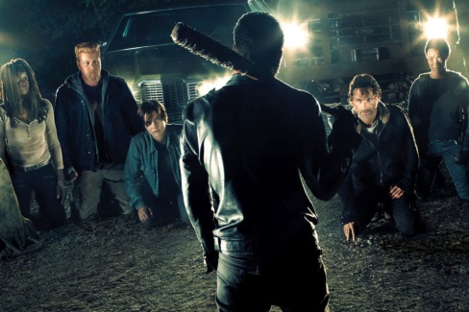
The conservative watchdog group blasted Sunday's episode, which featured the deaths of two series-regular characters being beaten to death by a guy with a baseball bat covered with barbed wire. "Last night’s season premiere of The Walking Dead was one of the most graphically violent shows we’ve ever seen on television, comparable to the most violent of programs found on premium cable networks," PTC president Tim Winter said Monday.
The Hollywood Reporter 10.25.16
http://www.hollywoodreporter.com/live-feed/walking-dead-violence-ptc-responds-940874

