Pay-for-Play Was Banned From Radio — But Texts Reveal It May Still Be Thriving
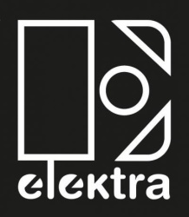
In June 2019, Mitch Mills, a senior vice president of radio promotion at Elektra Records, sent an urgent text to Steve Zap, an independent radio promoter who works with a number of stations in the adult contemporary format. The text shows that Mills was worried because Panic! at the Disco were receiving fewer plays than they had the previous week on a station Zap oversaw. “Stevie … [down] 11 in panic,” Mills wrote. “I just did a 2k deal with you … I need Panic back up.”
Rolling Stone 10.5.20
https://www.rollingstone.com/pro/features/pay-for-play-radio-texts-1067691/

