Peacock Introduces Live Feed Of Local NBC Stations
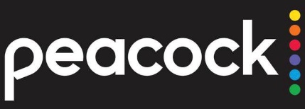
Peacock is adding a dedicated, geotargeted channel that will provide Premium Plus subscribers with live feeds of their regional NBC stations. All 210 affiliates are scheduled to be online before Nov. 30.
Deadline Hollywood 11.8.22
https://deadline.com/2022/11/peacock-live-streaming-local-nbc-affiliates-premium-subscribers-1235166669/

