Photojournalists are Risking Their Lives to Capture the Pandemic
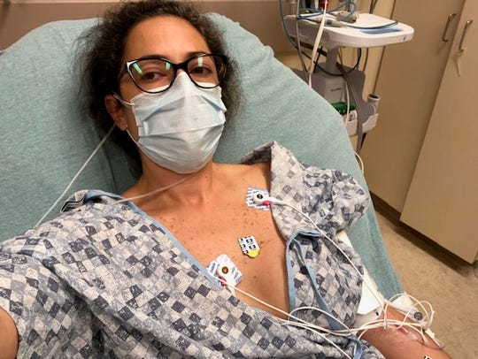
Newsrooms across the US have closed their offices in the wake of coronavirus outbreak to create the social distancing needed to slow the spread of the deadly illness. But while many journalists can do their jobs remotely — through phone calls, video calls and Slack messages — photographers continue to put themselves in harm's way to capture the pandemic from the front lines.
CNN Business 4.3.20
https://www.cnn.com/2020/04/03/media/photojournalists-coronavirus/index.html?utm_source=Listrak&utm_medium=Email&utm_term=Photojournalists+Risk+Lives+To+Capture+Pandemic&utm_campaign=For+Newsy%2c+Digital+Nativity+Aided+Its+Virus+Pivot
Image credit:
https://www.gannett-cdn.com/presto/2020/04/02/USAT/46bf8b98-f4b5-4dee-973f-d1443587ef67-image003.jpg?width=540&height=&fit=bounds&auto=webp

