FCC Reports Progress Against Illegal Radio Broadcasts
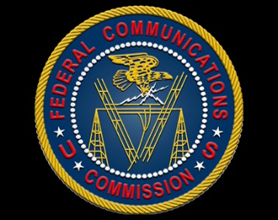
The FCC is using its authority under the Preventing Illegal Radio Abuse Through Enforcement Act to crack down on illegal radio broadcasts by monitoring the properties they originate from and warning property owners. The agency says it continues to increase staff and invest in vehicles and specialized hardware to tackle the issue.
Inside Radio 1/25/24
https://www.insideradio.com/free/fcc-tells-congress-it-remains-focused-on-property-owners-as-it-battles-radio-pirates/article_b956dd1c-bb4f-11ee-9e84-3fc60833989c.html

