Pirate Radio Landlords Face Fines Under FCC Crackdown
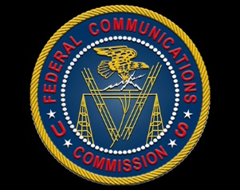
The Federal Communications Commission started prosecuting the owners of properties where pirate radio stations are based, exercising a power that the Protecting Intellectual Rights Against Theft and Expropriation Act recently gave it. Landlords could pay as much as $2 million if they know about such broadcasts and don't take measures to stop them.
Radio World (12/17)
https://www.radioworld.com/news-and-business/headlines/fcc-starts-crackdown-on-pirate-radio-landlords?utm_source=SmartBrief&utm_medium=email&utm_campaign=45863C53-9E40-4489-97A3-CC1A29EF491D&utm_content=D3E03982-96B2-468D-B94B-543254F82C27

