AMD: PlayStation 5 shortages May Go On For Another Year
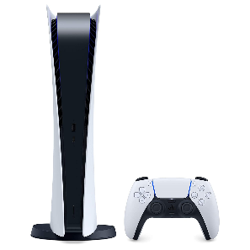
Lisa Su, the CEO of Advanced Micro Devices, doesn't see a quick end to the restocking issue with Sony's PlayStation 5 console, which uses AMD microchips. "I expect it to be from June-September of next year, 2022, when, perhaps, it will be possible to go down to a video game store or a department store to buy a PlayStation 5 or an Xbox Series X without it being an impossible task," Su says.
Tom's Guide 10.6.21
https://www.tomsguide.com/news/the-end-of-the-ps5-restock-nightmare-could-be-in-sight-amd-says?utm_source=SmartBrief&utm_medium=email&utm_campaign=3E572E13-3FBC-11D5-AD13-000244141872&utm_content=BB16977D-E879-4710-AA5B-53A1B4087048&utm_term=a25693a1-51b6-4112-bde4-56bd420e983f
Image credit:
https://mkuyu.co.tz/wp-content/uploads/2020/09/61JbCra7GL._SL1500_.jpg

