Pokémon Go Goes Viral With No Big Marketing Blitz
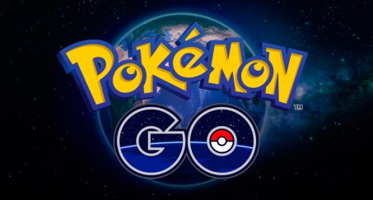
Pokémon Go hasn't had a single TV commercial, according to iSpot.tv, which monitors more than 100 networks around the clock. Beyond a familiar brand name, Pokémon Go seems to have won its out-of-nowhere success on the wings of core fans' anticipation and massive, unsolicited word of mouth on social media.
Advertising Age 7.11.16
http://adage.com/article/digital/pokemon-go-viral-marketing/304905/?utm_source=daily_email&utm_medium=newsletter&utm_campaign=adage&ttl=1468883274

