Political Ad Spend to Reach $8.8B in 2018
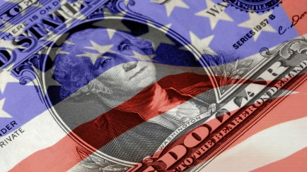
Investment in political advertising this year will rise 3.8% more than previously projected to hit $8.8 billion, per Borrell Associates. Broadcast television will take this year's biggest share of political ad spend, at almost 40% with digital taking just over 20%.
MediaPost Communications 4/24/18
https://www.mediapost.com/publications/article/318122/2018-political-ad-spend-grows-but-digital-media-d.html
Image credit:
http://www.pbs.org/election2016/issues/campaign-finance/

