2023 Political Ad Spend Could Break Records
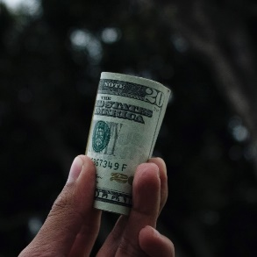
A total of $834 million was spent on political advertising for the 2024 presidential election in the first three quarters of 2023, a 75% increase over spending at the same point in the last presidential election cycle, AdImpact reports. Analysts say that combined investments for national, state and local races could push 2023 political spending to record levels despite a relatively low number of elections taking place this year.
Inside Radio 10/4/23
https://www.insideradio.com/free/adimpact-tallies-834-million-of-political-ad-buys-during-first-three-quarters-of-2023/article_82796c2a-634c-11ee-9342-b3b5a5b0b1d2.html
Image credit:
https://storage.googleapis.com/kaggle-datasets-images/295/645/9c8bcb9372b5a40c66961203c147cc3f/dataset-card.jpeg

