Kantar: Political Spend to Hit $2.4B
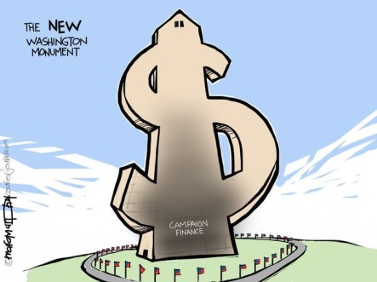
Political spending in 2018 is expected to hit $2.4 billion, up 14% from 2014, according to Kantar estimates. Cable will account for a 22% share, while digital will bring in a 16% share, according to the company's estimates.
TVNewsCheck 9/22/17
http://www.tvnewscheck.com/article/107524/kantar-stations-to-see-24b-political-in-18
Image source:
http://www.gannett-cdn.com/-mm-/3675c79e620b5245412be0122b549a858e00abda/c=0-4-2000-1500&r=x513&c=680x510/local/-/media/USATODAY/USATODAY/2014/04/06/1396787891004-040614lville-campfin.jpg

