GroupM Thinks Political Ad Spending Will Top $9.8B Next Year
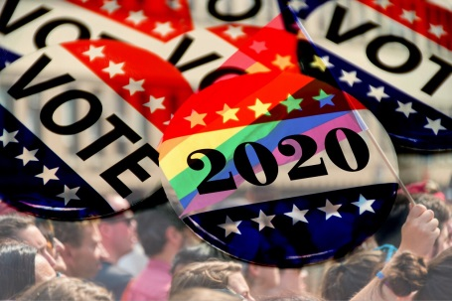
The amount spent on political advertisements in 2020 could hit record levels, passing $9.8 billion as federal elections loom and candidates vie to stay in the public eye, GroupM predicts. Big ad purchases like that of presidential candidate Michael Bloomberg, who spent $23.7 million on ads the week he announced his candidacy for the Democratic nomination, could drive ad spending even higher than projections suggest.
Inside Radio (free content) 12/5/19
http://www.insideradio.com/free/groupm-sees-billion-in-political-ad-spending/article_a941fd46-1737-11ea-9ace-736acb6d306e.html
Image credit:
http://globalequality.org/storage/images/Vote_2020_Flag.JPG

