Pondering the Future of Niche Cable Networks
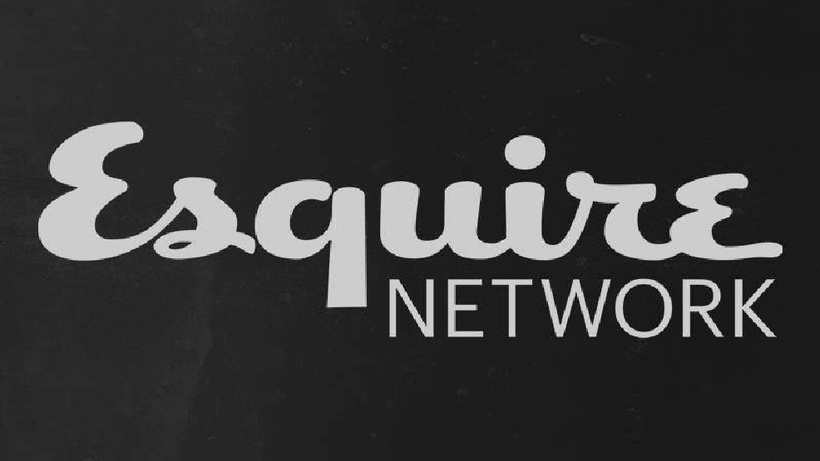
On Wednesday, owner NBCUniversal made it official. It’s shutting down the Esquire Network cable channel, which had fallen to just 45 million subscribers, though it will continue to offer a digital version of Esquire Network. At a time when cable carriage negotiations are becoming more barbed and cord cutting has led to an increase in skinny bundles, small cable channels face an uncertain future.
MediaLife 1.19.17
http://www.medialifemagazine.com/pondering-future-niche-cable-networks/

