Potentials And pitfalls Of Pay-To-Play Social Media
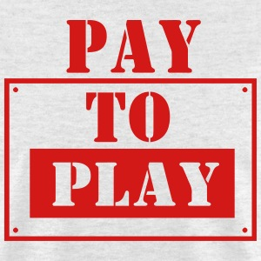
Twitter, Snap, YouTube, Discord and Meta's Facebook and Instagram are offering pay-to-play models that give paying consumers platform perks such as verification. The shift is likely to tip the scales among the volume of platform users who are reluctant to pay, while brands may benefit from the boost of "perceived credibility" and shift in algorithms that favor their content, say experts.
Vox 2/21/23
https://www.vox.com/recode/2023/2/21/23609375/meta-verified-twitter-blue-checkmark-badge-instagram-facebook
Image credit:
https://image.spreadshirtmedia.com/image-server/v1/compositions/106263543/views/1,width=300,height=300,appearanceId=351,version=1440417743/pay-for-play-t-shirts-men-s-t-shirt.jpg

