Nielsen's Miniature Meter is a "Game Changer"
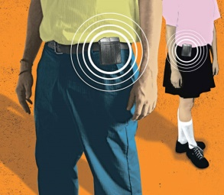
Nielsen is experimenting with a smaller-sized Portable People Meter that could be embedded into wearables. The stylish new prototypes are a "game changer" because they measure beyond just radio, writes Charlie Sislen of Research Director.
Inside Radio 5/22/17
http://www.insideradio.com/free/nielsen-looks-to-change-game-with-next-gen-ppm/article_3fda7168-3ecb-11e7-a71b-7bfb87282ad0.html
Image credit:
http://archive.wired.com/images/article/magazine/1509/st_arbitron_f.jpg

