PR Pro: How to Craft a Good Apology
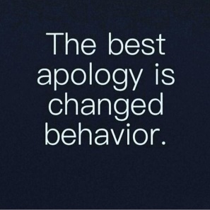
Corporate apologies are becoming more common, and canned public relations statements often fall short in their effort to garner forgiveness, writes Terry Nguyen. In this interview, Sean O'Meara, PR pro and author of "The Apology Impulse," describes "the worst apology archetypes," discusses lackluster efforts by leading brands such as United Airlines and Facebook and offers tips for crafting authentic contrition that will win back consumers.
Vox 11/14/19
https://www.vox.com/the-goods/2019/11/14/20961662/brand-apology-sorry
Image credit:
https://www.lovethispic.com/uploaded_images/233725-The-Best-Apology-Is-Changed-Behavior.jpg

