Press Foundation Documents At Least 100 Different “Incidents Of Aggressions” Against Media During Weekend Of Protests
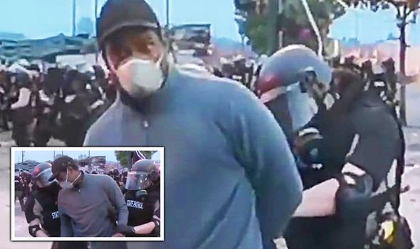
Of the more than 60 assaults on journalists they have tracked, 10 include damage to news equipment. Still to be determined is how many of the incidents involved police action against journalists covering the protests, as reporters shared stories of being injured by members of law enforcement.
Deadline Hollywood 5.31.20
https://deadline.com/2020/05/george-floyd-protests-media-nbc-news-garrett-hake-ali-velshi-1202947944/
Image credit:
https://cdn.images.express.co.uk/img/dynamic/78/590x/cnn-news-arrest-live-minneapolis-riot-1288690.jpg?r=1590749174463

