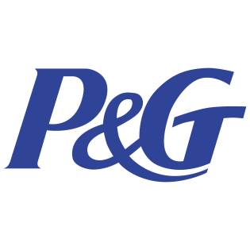
P&G Leads Radio Advertisers In 2021
Procter & Gamble ran 9.1 million commercials in 2021, up 55% from 2020, making it the most prolific radio advertiser of the year. The US government took second place with 5.4 million ads.
Inside Radio (free content) 1/19/22
http://www.insideradio.com/free/p-g-unseats-uncle-sam-as-radio-s-top-advertiser-of-2021/article_e3ba8aa6-78f6-11ec-ab83-0f1a63505064.html

