Programmatic TV Now Part of Google's DoubleClick Bid Mana
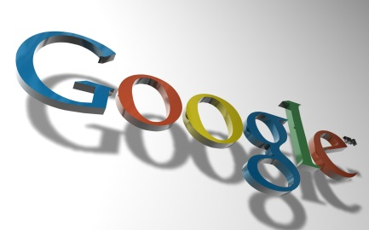
Google is letting advertisers buy linear TV ads programmatically via DoubleClick Bid Manager, which will help bridge the gap between digital and traditional television advertising. "For example, an advertiser will be able to measure the lift when someone searches for their brand on Google or YouTube after seeing their TV ad," Google's Rany Ng wrote in a blog post.
VentureBeat 4.24.17
https://venturebeat.com/2017/04/24/google-adds-tv-inventory-to-doubleclick-bid-manager-so-advertisers-can-measure-video-campaigns-across-linear-and-digital/

