Proximity Mobile Pay Is On The Rise Worldwide
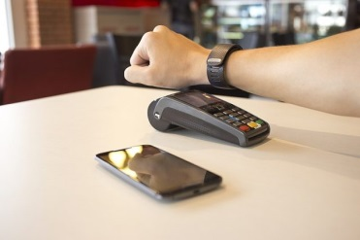
In 2020, more than 1.18 billion people used proximity mobile payments worldwide, a growth of 22.2% over 2019. By 2022, proximity mobile payments will reach close to 1.35 billion people worldwide as the payment method's popularity increases.
eMarketer 9.8.21
https://www.emarketer.com/content/proximity-mobile-pay-on-rise-worldwide?ecid=NL1014
Image credit:
https://corepay.net/wp-content/uploads/2020/02/800px-NFC-Payment-With-Watch-640x427.jpg

