PTC Highlights 2019’s Best & Worst TV Advertisers
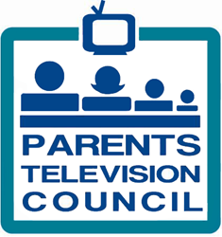
“Advertisers are the lifeblood of TV programs, and the kind of content they sponsor matters greatly. Our recent research has shown TV programs are getting more violent and have increased profanity, which is extremely concerning to families. Advertisers have the power to change TV for the better and reverse these trends. Those advertisers on our Best List are sponsoring programming that is generally safe for kids and families to watch. Advertisers on our Worst List need to improve their TV ad buys,” said PTC President Tim Winter.
TVNewsCheck 11.19.19
https://tvnewscheck.com/article/more-news/241395/ptc-highlights-2019s-best-worst-tv-advertisers/?utm_source=Listrak&utm_medium=Email&utm_term=PTC+Highlights+2019%e2%80%99s+Best+%26amp%3b+Worst+TV+Advertisers&utm_campaign=ABC+Stations+Top+Social+Media+Excellence+Awards
Parents Television Council
http://w2.parentstv.org/Main/

