Pulitzer Board to Debut Award for Audio Journalism In 2020
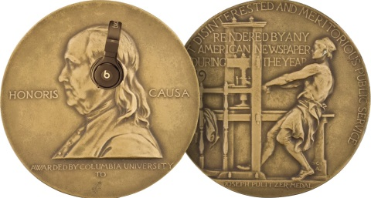
Radio broadcasters, newspapers and podcasters producing audio journalism that serves the public will be eligible for Pulitzer awards next year as the organization's board tests a prize for audio reporting. The addition of the category brings the total number of awards up to 15 and marks the first change to the prize's structure since 2007.
Nieman Journalism Lab 12/6/19
https://www.niemanlab.org/2019/12/in-2020-podcasts-will-be-able-to-win-pulitzers-oh-and-radio-too
Image credit:
https://www.niemanlab.org/images/pulitzer-audio.jpg

