QR Codes: The Shiny New Marketing Tool for CTV
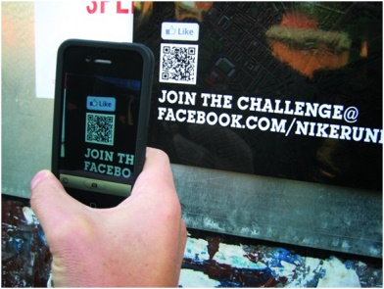
Innovid reports that the number of brands using QR codes on connected television jumped 160% between the first and second quarters of this year. Impressions from the technology increased 62% year-over-year for the second quarter and 130% from Q2 to Q3.
MediaPost Communications 11.27.20
https://www.mediapost.com/publications/article/358170/the-qr-code-also-rises-for-now.html
Image credit:
http://carcareconnect.com/wp-content/uploads/sites/2/2013/09/QR-Code-Facebook-Like.jpg

