QVC to Buy HSNi in $2.1B Stock Deal
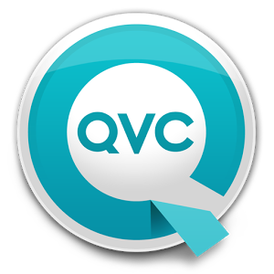
Liberty Interactive, the parent of shopping network QVC, will acquire the 62% of competitor HSNi that it doesn't already own in a $2.1 billion stock deal, the companies said Thursday. After the deal closes, Liberty will create a new company called QVC Group, which will include the merged company's cable operations and other divisions including flash-sale fashion site Zulily.
CNBC 7/6/17
http://www.cnbc.com/2017/07/06/liberty-interactive-to-buy-hsn-in-deal-valued-at-2-point-1-billion.html

