Radio Groups Diversify Amid Digital Transformation
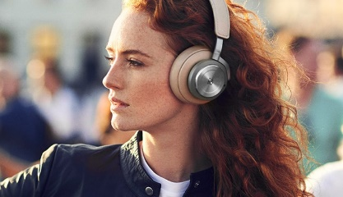
A growing number of radio companies are pivoting to position themselves as audio brands embracing digital channels, podcasting and social media to meet their audiences on new listening platforms. Many organizations are forging new partnerships and rolling out new offerings to maintain existing audiences and reach new listeners.
Radio World 2.24.21
https://www.radioworld.com/news-and-business/headlines/for-radio-audio-is-the-new-now?utm_source=SmartBrief&utm_medium=email&utm_campaign=45863C53-9E40-4489-97A3-CC1A29EF491D&utm_content=3C8CB4F7-195F-41B9-8330-20D9B56A1389
Image credit:
https://majorhifi.com/wp-content/uploads/b-and-o-h9.jpg

