Radio Reaches More Americans Than Any Other Platform
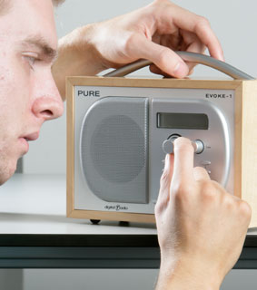
Radio reaches 93% of the US adult population every week, edging out TV, smartphones and other media platforms, a Nielsen report states. The report found that around 228 million adults listened to radio at least once per week during 2016's fourth quarter, revealing radio's significant reach.
Business Insider 7/3/17
http://www.businessinsider.com/radio-vs-tv-smartphones-reach-in-us-chart-2017-7
Image credit:
https://www.ofcom.org.uk/__data/assets/image/0025/5875/radio.gif

