Radio Revenue Reached $15B In 2023
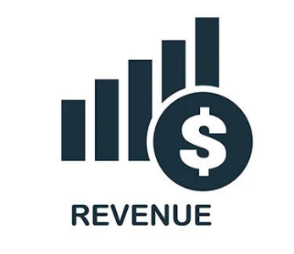
Ad revenue in the radio industry reached $15.15 billion last year despite decreases in advertiser spending, Kagan Research reports. Kagan senior research analyst Justin Nielson says, "[R]adio's lower ad cost, community outreach and relatively high return on investment compared to other media should help maintain its ad share in its local markets."
Inside Radio 2/27/24
https://www.insideradio.com/free/kagan-radio-industry-revenue-topped-15-billion-in-2023/article_9460e25e-d545-11ee-aead-035bdc846ad3.html
Image copyright:
https://bloximages.newyork1.vip.townnews.com/insideradio.com/content/tncms/assets/v3/editorial/0/ea/0eac14cc-e3ff-11ed-8744-bf962488aa38/6448ca76d0c95.image.jpg

