What the $2 Trillion Coronavirus Relief Bill Means For the Entertainment Industry
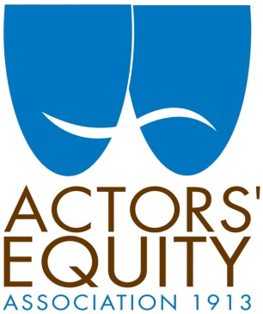
Kate Shindle, the president of Actors Equity Association, said that she was “encouraged by the provisions of the new Senate bill, which will make it easier for arts professionals to get the unemployment assistance they need for work they had booked, but not yet started.”
Deadline Hollywood 3.25.20
https://deadline.com/2020/03/coronavirus-congress-entertainment-1202891947/

